**Section 1.2**

**Section 1.5**

I’m going to be real with you here, I wasn’t sure what I was doing so I just compared the value of t from the example input in section 1.1 to what I got from prediction in section 1.4 and got:

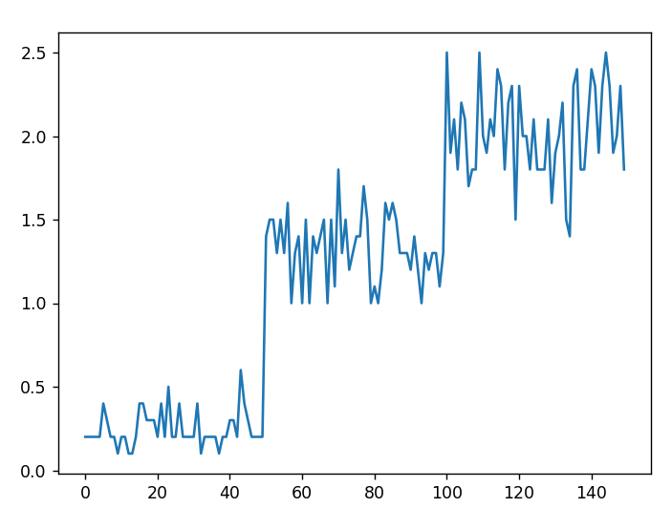**For t (real value):**

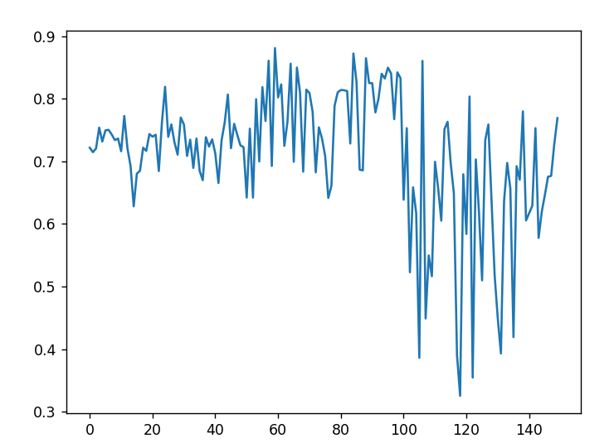**For prediction (predicted value):**

We can see from these two pictures that the predictions are way off, so either I’m doing this horribly wrong or I’m comparing the wrong data.